A+ Computer Science Recursion - RECURSIVE CIRCLES Lab Value - 100

Lab Goal : This lab was designed to teach you more about recursion.

Lab Description : Use recursion to draw a series of circles on the screen.

Example of recursion – type this in to an old program
and run it to see how it works. Change the value
passed from the main to see how it affects the output.

public void demo( int x )
{
if( x > 0 )
OUTPUT
20
15
10
5
{
System.out.println(x);
demo(x-5);
}
}

//code in main
prog.demo(20);

Sample Output :

LAB21A – In lab21a, you are to complete the recursive drawCircles() method so that it will draw all of the circles in the image below. It currently only draws the first and smallest circle.

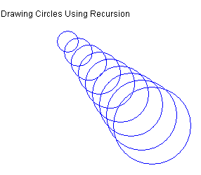
Files Needed ::
RecursiveCircles.java
GraphicsRunner.java

